Data Structures and Algorithms IT2070
Year two Semester two 2020
Online Examination
Sri Lanka Institute of Information Technology
Time: 30 minutes
________________________________________________________________________

Paper Number 4 (20 marks)

The power function can be defined as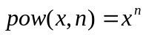. This can be evaluated using the multiplication as 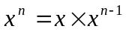 where x is any real number and n is a non-negative integer. [Hint: 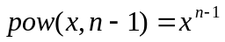]

A recursive algorithm for the power calculation is given below:
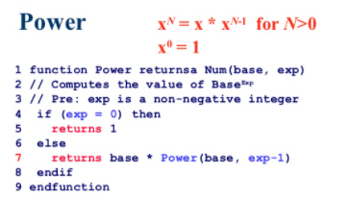

- Write a program in Python to read an integers from the keyboard for x and n.
- Develop a function in python named as power and implement the above recursive algorithm.
- Pass the input numbers as parameter to the function developed and get the power of number as output.
- Use the loop to run the program and display the correct output until user inputs -1.

Upload your answer using given template to the course web link “Paper Number 4”

Grading Sheet:
- Program is compiling. 2 marks
- Program is running successfully. 2 marks
- Program takes the input number as integer. 2 marks
- Correct implementation power function. 6 marks
- Display the output correctly 2 marks
- Use of loop correctly 4 marks
- Include comments and properly indented. 2 marks
- Plagiarism testing tool results:…………………………..

